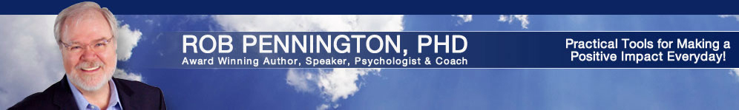
BIOGRAPHY

- Ph.D. in Educational Psychology (UT-Austin 1976)
- Organizational Consultant and Executive Coach
- Award Winning Professional Speaker & Author
- Highest Rated Trainer by ExxonMobil every year for 35 years

Resource International co-founder, Dr. Rob Pennington, is an educational psychologist who specializes in improving the performance of leaders and teams through a balance of authority and collaboration. Trained through the National Training Laboratory (NTL) in organizational development in the early 70's and a former faculty member of three universities,
Dr. Pennington’s decades of research and experience support organizations in developing executives who can successfully lead massive change. His extensive work with CEOs and their Leadership Teams allows him to efficiently produce more effective results than might otherwise be achieved, always with an eye on the bottom-line and the ROI of his engagements. References available online.

Completing his Ph.D. in educational psychology (1976) from the University of Texas at Austin, Rob received UT’s Outstanding Student Award while completing his B.A. in computer science and psychology (1970). As a graduate student he co-taught Group Dynamics & Interpersonal Relationships with Ellott Aronson, Ph.D., and worked with Frances Fuller, Ph.D. and Ollie Bown, Ph.D. at the R&D Center for Teacher Education where he develop practical applications of the Concerns Based Adoption Model and co-developed The Interdisciplinary Faculty Teaming Manual and Workshop.

Organizational Consultant and Executive Coach
Dr. Pennington works in-depth with organizations to support managers tasked with leading stressful and rapid change. Coaching executives to more effectively integrate interpersonal skills into their leadership styles, he has consulted with the U.S. Navy during base closings; supported the Architect of the Capitol to enhance supervisory skills; coordinated NASA's Johnson Space Center assessment of it's workforce's effectiveness in dealing with change; assisted employees of British Petroleum and Amoco in addressing their merging of different corporate cultures and supported Houston Medical Center executives through leadership, team and business consulting. More at: www.DrRobPennington.com/coaching.php.

Speaker
A keynote presenter for numerous national associations, e.g., the National Safety Council, Meeting Professionals International and the American Society of Association Executives, Dr. Pennington's speaking style is known to be refreshingly informal and uniquely engaging. He involves his audience directly as few professional speakers can, making complex issues understandable in an entertaining common-sense manner. His insights and delivery make him one of today's most impactful, engaging and memorable speakers. Four-time recipient of Mental Health America’s Outstanding Speaker Award and one of Meeting Professionals International's original Platinum Presenters Dr. Pennington is consistently rated, "one of the best presenters I've ever heard". You can count on Rob to create a memorable and transforming program for your organization.

His 'signature story' of having been shot in the center of his chest by an unknown assailant armed with a 38-caliber gun amazes every audience. Dr. Pennington’s presentations include many practical tools and techniques, which he uses himself in dealing successfully with the everyday challenges of being self-employed while also having cared for a spouse for 10 years challenged with multiple sclerosis until her passing in 2009. The insights and wisdom he shares represent a credibility born of extensive academic research and profound personal experience. Information about having Dr. Pennington speak to your next event is available at: www.DrRobSpeaks.com.

Trainer
His multiday, highly interactive seminars, Successfully Managing the Stress of Change and Successful Work Relationships have become standard "flagship trainings" in some of our nation's largest organizations, being offered between 50-120 days a year to Fortune 100 employees for over 25 years. He has received the highest trainer evaluations from ExxonMobil employees every year for 35 years.
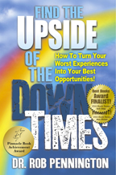
Author
In his award winning autobiographical self-help book, Find the Upside of the Down Times: How To Turn Your Worst Experiences into Your Best Opportunities (Amazon & Kindle), Dr. Pennington provides readers with insights and tools to turn life’s challenges into opportunities for growth and even blessings. He shares his own very personal journey of survival and discovery after some of the biggest challenges life can throw.
Speed Through Stress in 5 Steps in 15 Seconds (video and workbook) is Dr. Pennington’s latest product for helping anyone recognize their stress quicker and more through it faster. Available free at: www.SpeedThroughStress.com

